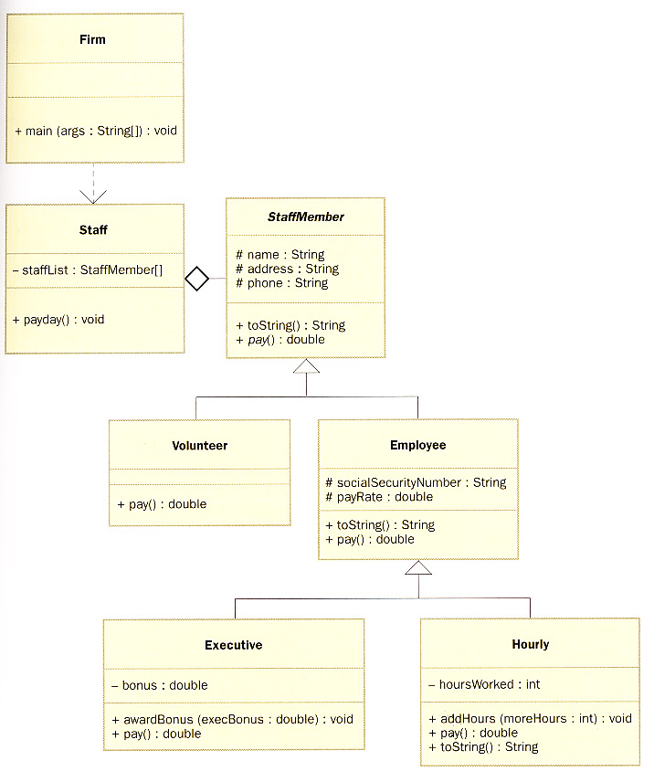

**SAMPLE CODE**

**Firm.java**

public class Firm

{

public static void main (String[] args)

{

Staff personnel = new Staff();

personnel.payday();

}

}

**Staff.java**

public class Staff

{

private StaffMember[] staffList;

public Staff ()

{

staffList = new StaffMember[6];

staffList[0] = new Executive ("Sam", "123 Main Line",

"555-0469", "123-45-6789", 2423.07);

staffList[1] = new Employee ("Carla", "456 Off Line",

"555-0101", "987-65-4321", 1246.15);

staffList[2] = new Employee ("Woody", "789 Off Rocker",

"555-0000", "010-20-3040", 1169.23);

staffList[3] = new Hourly ("Diane", "678 Fifth Ave.",

"555-0690", "958-47-3625", 10.55);

staffList[4] = new Volunteer ("Norm", "987 Suds Blvd.",

"555-8374");

staffList[5] = new Volunteer ("Cliff", "321 Duds Lane",

"555-7282");

((Executive)staffList[0]).awardBonus (500.00);

((Hourly)staffList[3]).addHours (40);

}

public void payday ()

{

double amount;

for (int count=0; count < staffList.length; count++)

{

System.out.println (staffList[count]);

amount = staffList[count].pay();

if (amount == 0.0)

System.out.println ("Thanks!");

else

System.out.println ("Paid: " + amount);

System.out.println ("-----------------------------------");

}

}

}

**StaffMember.java**

abstract public class StaffMember

{

protected String name;

protected String address;

protected String phone;

public StaffMember (String eName, String eAddress, String ePhone)

{

name = eName;

address = eAddress;

phone = ePhone;

}

public String toString()

{

String result = "Name: " + name + "\n";

result += "Address: " + address + "\n";

result += "Phone: " + phone;

return result;

}

public abstract double pay();

}

**Volunteer.java**

public class Volunteer extends StaffMember

{

public Volunteer (String eName, String eAddress, String ePhone)

{

super (eName, eAddress, ePhone);

}

public double pay()

{

return 0.0;

}

}

**Employee.java**

public class Employee extends StaffMember

{

protected String socialSecurityNumber;

protected double payRate;

public Employee (String eName, String eAddress, String ePhone,

String socSecNumber, double rate)

{

super (eName, eAddress, ePhone);

socialSecurityNumber = socSecNumber;

payRate = rate;

}

public String toString()

{

String result = super.toString();

result += "\nSocial Security Number: " + socialSecurityNumber;

return result;

}

public double pay()

{

return payRate;

}

}

**Executive.java**

public class Executive extends Employee

{

private double bonus;

public Executive (String eName, String eAddress, String ePhone,

String socSecNumber, double rate)

{

super (eName, eAddress, ePhone, socSecNumber, rate);

bonus = 0;

}

public void awardBonus (double execBonus)

{

bonus = execBonus;

}

public double pay()

{

double payment = super.pay() + bonus;

bonus = 0;

return payment;

}

}

**Hourly.java**

public class Hourly extends Employee

{

private int hoursWorked;

public Hourly (String eName, String eAddress, String ePhone,

String socSecNumber, double rate)

{

super (eName, eAddress, ePhone, socSecNumber, rate);

hoursWorked = 0;

}

public void addHours (int moreHours)

{

hoursWorked += moreHours;

}

public double pay()

{

double payment = payRate * hoursWorked;

hoursWorked = 0;

return payment;

}

public String toString()

{

String result = super.toString();

result += "\nCurrent hours: " + hoursWorked;

return result;

}

}